EXP NO-12
EMBEDDED C PROGRAM TO CONVERT THE HEXADECIMAL DATA 0XCFH TO DECIMAL AND DISPLAY THE DIGITS ON PORTS P0, P1AND P2
AIM:
To write an Embedded C program to convert Hexadecimal numbers into Decimal and display the digits on ports using Keil software.
PROGRAM
#include <reg51.h>
void main()
{
unsigned char hex = 0xCF;
unsigned int decimal;
unsigned char hundreds, tens, ones;
decimal = hex;
hundreds = decimal / 100;
tens = (decimal % 100) / 10;
ones = decimal % 10;

P0 = hundreds;
P1 = tens;
P2 = ones;

while(1);
}

SIMULATION
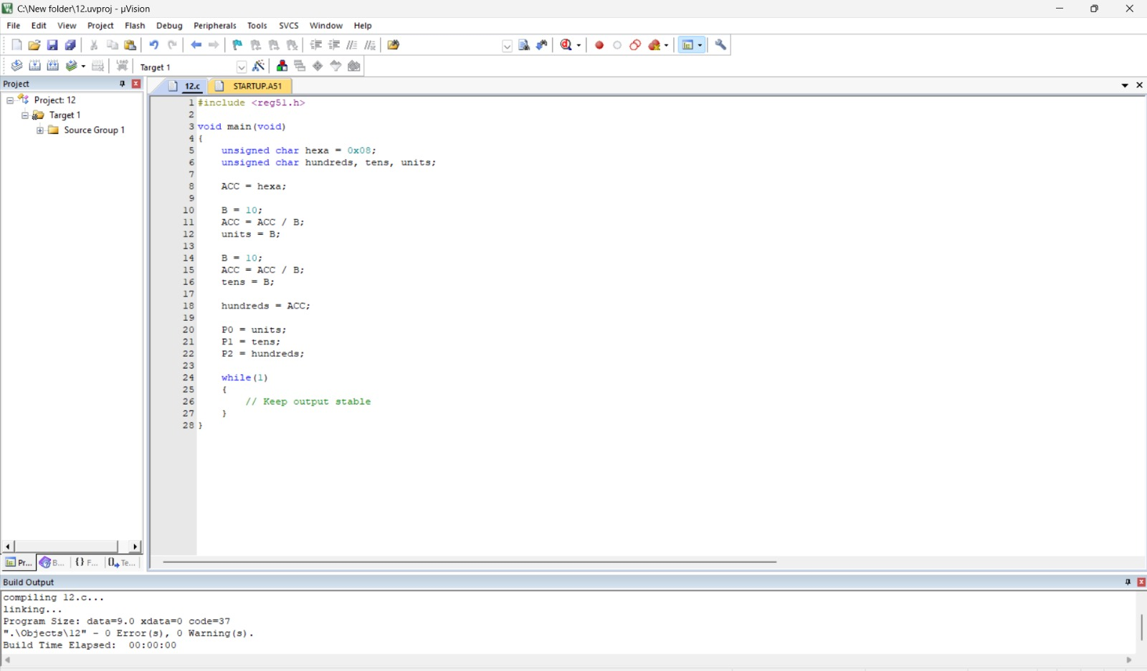
OUTPUT 